Quantum AI VS traditional ai's

how Humanity is going to make more human minds in a computer
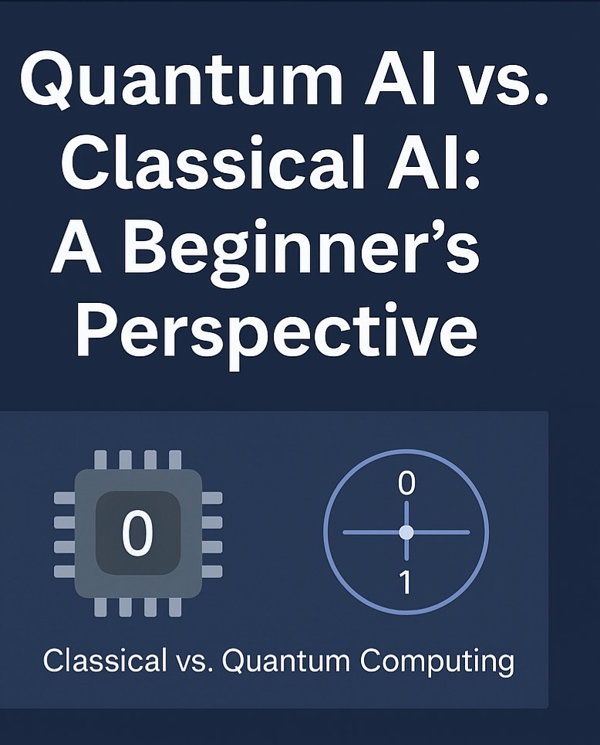

A comparison between Ai programs runed in a quantum computer and a normal computer

INTRODUCTION
Artificial Intelligence has reshaped how we interact with technology, enabling machines to recognize speech, play games, and even diagnose diseases. But as problems get more complex, classical AI starts hitting limits. That’s where quantum computing comes in. It promises to make AI way more powerful by changing how we process information. In this paper, we’ll explore what classical AI is, how quantum AI is different, and why this shift could be game-changing.

●Classical AI – How It Works
Classical artificial intelligence (AI) encompasses a range of algorithms and statistical models designed to identify patterns and make decisions based on data. Operating on classical computing architecture, which processes information using binary bits (0s and 1s), these systems rely on deterministic logic and rule-based operations. Prominent approaches within classical AI include machine learning models such as neural networks, decision trees, and support vector machines. These models are trained on large datasets to optimize their ability to make accurate predictions or classifications. Neural networks, inspired by the structure of the human brain, are particularly effective for tasks involving image and speech recognition, while decision trees are valued for their interpretability, and support vector machines for their robustness in high-dimensional spaces. The performance of these models is heavily dependent on computational resources, as training complex models on large-scale data requires significant processing power and memory. As such, advances in classical AI have been closely tied to developments in hardware and parallel processing technologies.

●Quantum AI – What’s New Here:-
Quantum artificial intelligence (Quantum AI) integrates the principles of quantum computing with machine learning to unlock new levels of computational performance and problem-solving capability. Unlike classical computers that rely on binary bits (0 or
1), quantum computers utilize quantum bits, or qubits, which can exist in a superposition of states—both 0 and 1 simultaneously. Additionally, qubits can be entangled, meaning the state of one qubit can instantaneously influence the state of another, regardless of the distance between them. These properties allow quantum systems to process a vast number of potential outcomes in parallel, providing a substantial advantage for solving complex optimization, search, and sampling problems that are computationally intensive for classical systems. By leveraging these quantum phenomena, Quantum AI holds the potential to develop more efficient, faster, and potentially more intelligent algorithms for tasks such as pattern recognition, drug discovery, financial modeling, and cryptography. While still in the experimental phase, ongoing research suggests that the synergy between quantum computing and artificial intelligence could redefine computational boundaries in the coming decades.

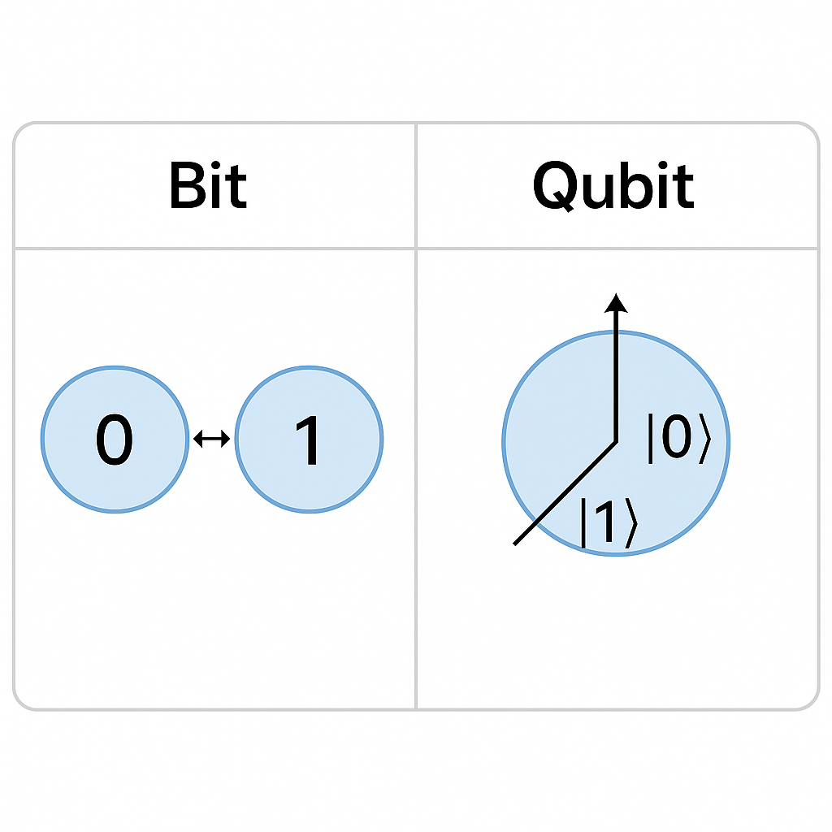
●Key Differences Between Classical and Quantum AI
Classical and quantum AI differ fundamentally in their underlying computational principles, leading to distinct capabilities and limitations. One of the primary distinctions lies in data representation: classical AI systems operate using bits, which exist in a state of either 0 or 1, whereas quantum AI utilizes qubits, which can exist in a superposition of both 0 and 1 simultaneously. This enables quantum systems to represent and process significantly more complex data structures.

In terms of speed and parallelism, quantum AI offers the potential to evaluate multiple solutions at once due to its inherent quantum parallelism. While classical AI typically processes tasks sequentially or relies on parallel computing architectures to improve performance, quantum AI can explore a vast solution space more efficiently, particularly in optimization and probabilistic reasoning tasks.

The hardware requirements also set the two apart. Classical AI runs on traditional silicon-based processors and is supported by mature, scalable hardware infrastructure. In contrast, quantum AI requires quantum processors that leverage phenomena such as superposition and entanglement. These processors are still in the early stages of development, often requiring highly controlled environments, such as cryogenic temperatures, to maintain qubit stability.

Lastly, their current and potential applications reflect their respective technological maturity. Classical AI currently dominates across industries, powering applications in healthcare, finance, logistics, and natural language processing. However, quantum AI is poised to revolutionize fields such as materials science, cryptography, financial modeling, and potentially even brain simulation, by solving problems that are intractable for classical systems.

●Current Limitations
While the potential of quantum artificial intelligence (QAI) is significant, quantum computers remain in the early stages of development. Current quantum hardware is extremely expensive to build and maintain, often requiring ultra-low temperatures, precise environmental controls, and advanced error correction to function reliably. Qubits are highly sensitive to external disturbances, making quantum systems fragile and prone to decoherence, which limits their practical use in real-world scenarios. Furthermore, access to quantum computing resources is currently restricted to specialized research institutions, national laboratories, and a few leading technology companies, creating barriers to widespread experimentation and deployment.

It is also important to note that not all AI problems are well-suited for quantum approaches. Many conventional machine learning tasks may not experience significant performance gains when transitioned to quantum platforms, particularly when classical methods are already highly optimized. The advantage of QAI is believed to lie in solving specific types of problems—such as combinatorial optimization, quantum chemistry simulations, and high-dimensional data analysis—where classical methods face exponential slowdowns. However, identifying these problem domains with clarity requires further theoretical and empirical research.

As the field progresses, researchers are focused on developing hybrid models that integrate classical and quantum techniques, designing quantum algorithms tailored for AI, and advancing quantum hardware stability and scalability. Continued investment in these areas will be crucial to understanding where QAI can deliver the greatest transformative impact and how it can be integrated into practical, large-scale applications.

●Conclusion and Future Scope
Quantum AI is still an emerging field, but it holds transformative potential for the future of computing and intelligent systems. Although current implementations are limited by hardware constraints and theoretical maturity, ongoing advancements in quantum processors, error correction techniques, and quantum algorithms suggest that a new class of AI systems may soon become viable—ones that can outperform classical models in specific, complex problem domains. These next-generation systems could redefine capabilities in fields such as cryptography, logistics, climate modeling, and biological systems simulation by solving challenges that are currently beyond the reach of classical AI.

Given this outlook, it is imperative that students, educators, and early-career researchers begin to engage with quantum AI concepts at an early stage. Familiarity with quantum mechanics, linear algebra, and fundamental machine learning principles provides a strong foundation for understanding and contributing to this interdisciplinary space. Educational institutions and online platforms are increasingly offering introductory courses and open-access tools that lower the barrier to entry. By building knowledge now, the next generation of scientists and engineers will be better equipped to shape the direction of QAI, drive innovation, and potentially contribute to paradigm-shifting discoveries. Encouraging early exploration not only prepares future talent but also fosters a diverse and collaborative research community capable of unlocking the full promise of quantum-enhanced artificial intelligence.

●Reference documents
IBM Qiskit Documentation - https://qiskit.org/documentation/

"Quantum Machine Learning" by Maria Schuld & Francesco Petruccione

arXiv: Quantum Machine Learning survey - https://arxiv.org/abs/2101.11020

Xanadu's PennyLane QML Tools - https://pennylane.ai/

Quantum AI Overview (MIT Tech Review) - https://www.technologyreview.com/2021/05/03/1024551/quantum-ai-google-research/

About The Author:-
I’m a 16-year-old student passionate about AI, quantum computing and simulating the human brain inside a quantum computer. This paper is part of my early exploration into future tech that could change the world. It is written from a beginner's perspective to help other curious minds understand the next wave of computing

